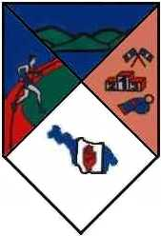
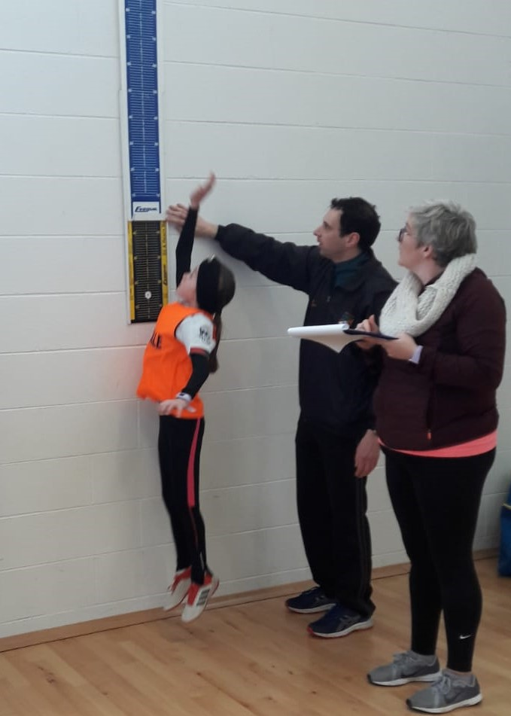
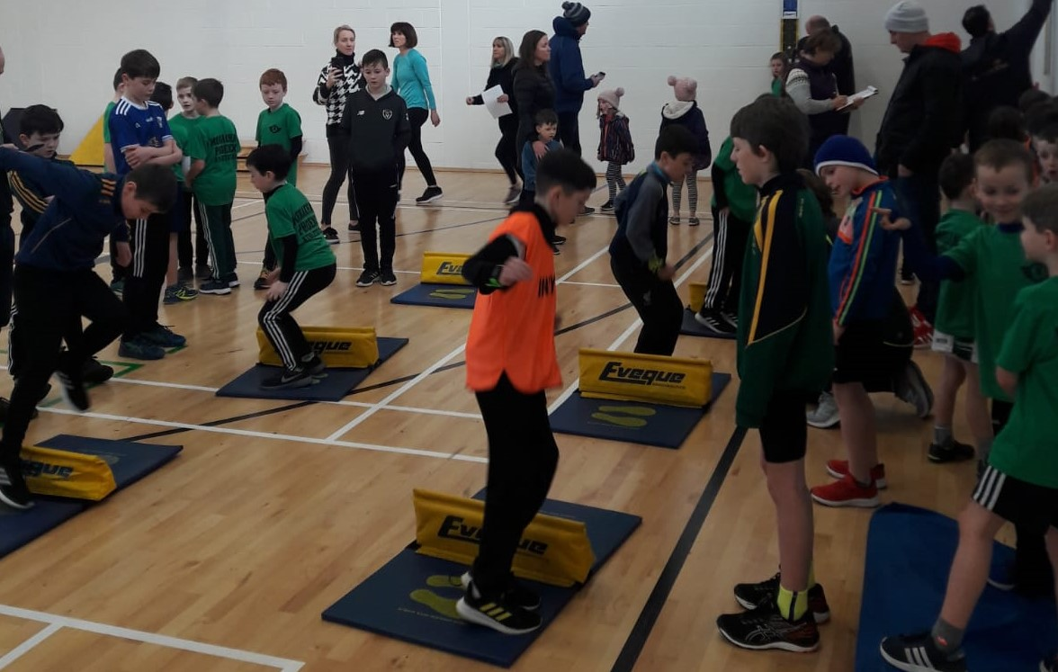
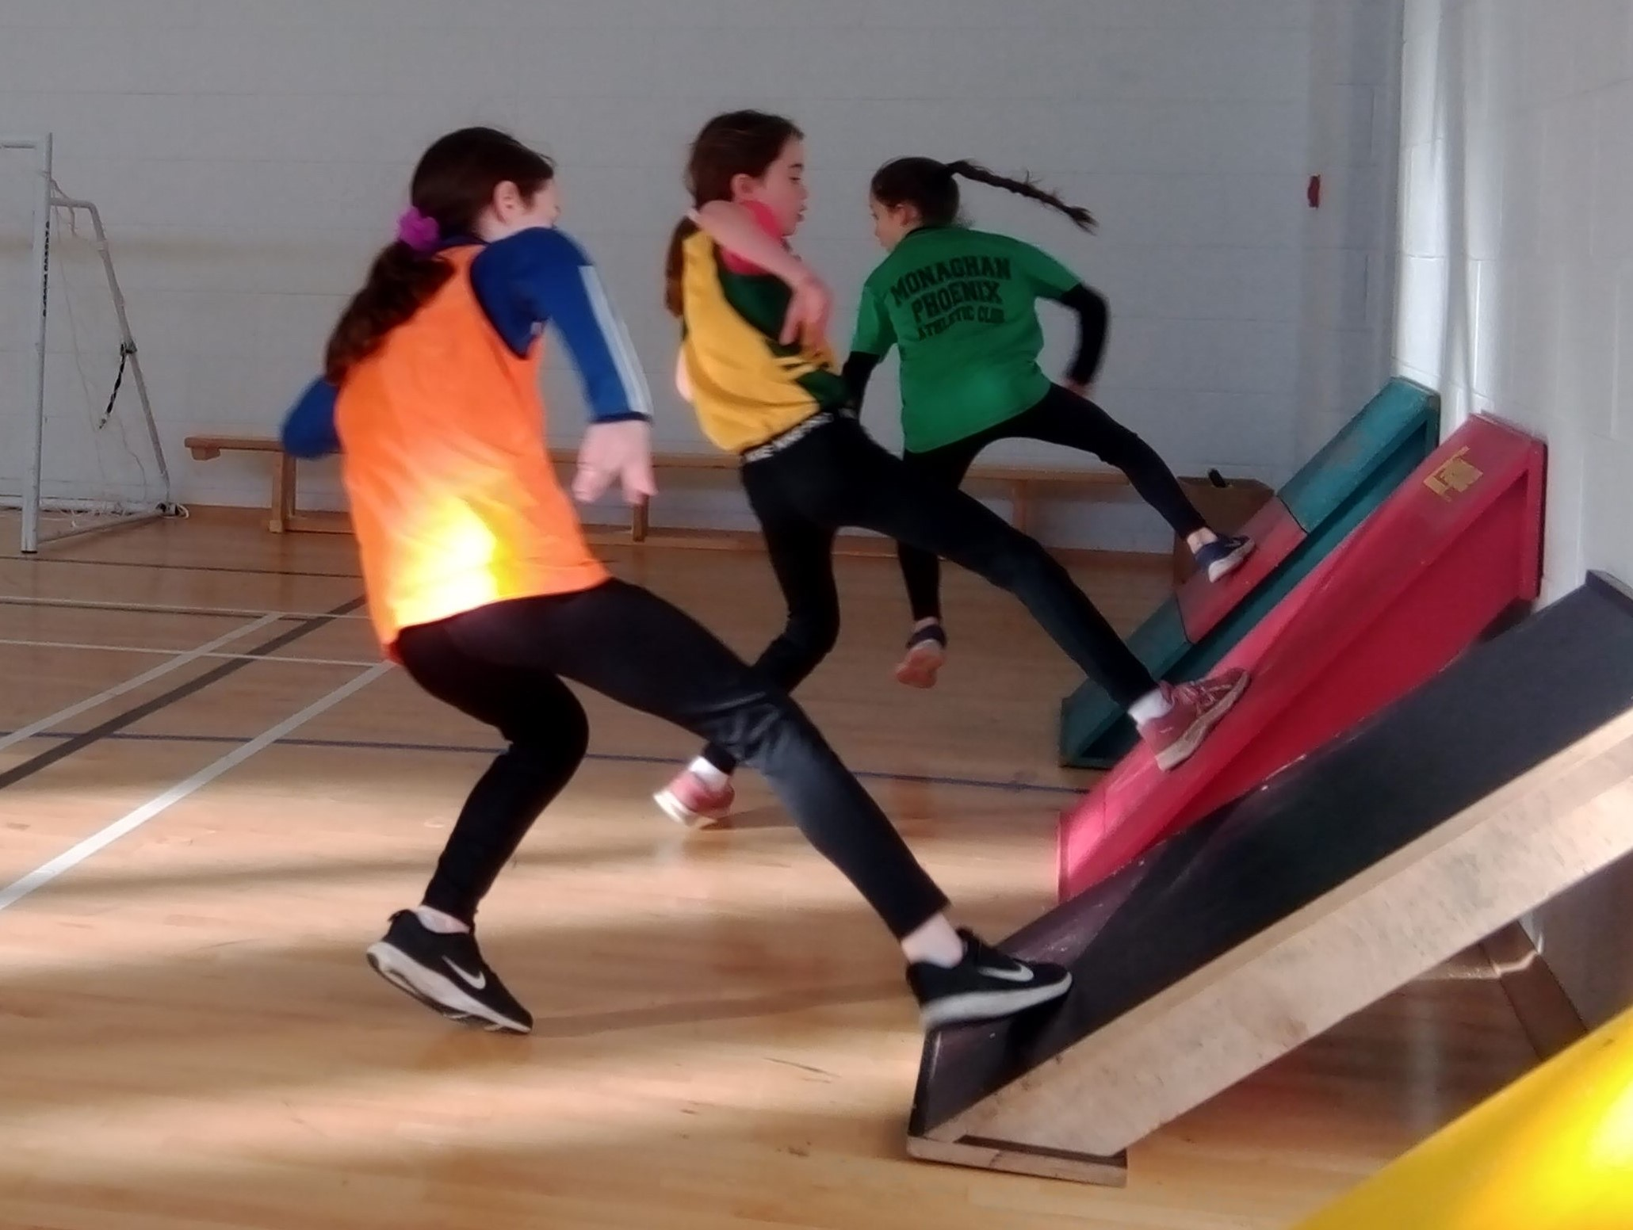
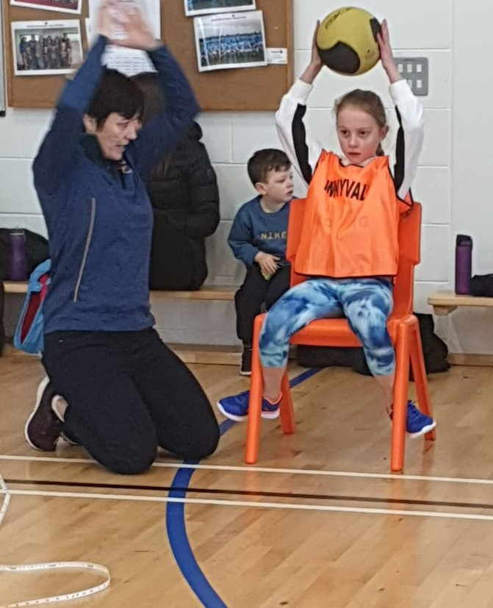
Cavan Sportshall Competition, Breffni College, 19 January
A small group of Innyvale athletes took part in the Cavan Sportshall competition on Sunday 19th January in Breffni College, Cavan. Joined by athletes from across Cavan and from Monaghan Phoenix AC, our squad of under 9 to 11s had an enjoyable morning of athletics featuring a mix of sprints, jumping and throwing events, finishing with team relays.

The Sportshall events are all about fun and providing a low pressure introduction to competition and there will be a second event in mid-February.

Well done to Haley, Flynn, Kaitlin, Ciara, Bethan and Tynan.

Ulster Shot Putt Gold For Casey Mulvey, 4 February 2020

The 2020 Ulster Indoor Track & Field Championships were held at the National Indoor Arena in Abbotstown over the weekend and our own Casey Mulvey took part in the shot putt event. Throwing the 3kg weight out to 14.13 metres, Casey not only took the gold medal in the Under 18 age group, but according to the results she had the best throw of all age groups, including the senior women.

Well done Casey and best of luck in the All-Ireland's next month.

Cavan Spring League Day 1, 23rd February 2020

The first of two days of the Cavan Athletics' Spring League took place on a Sunday 23rd February at the PeaceLink track in Clones. The crisp but dry winter's morning saw a wide variety of Cavan's athletes in action, from the youngest age groups right up to masters category. Innyvale AC had a good turnout from our athletes with 15 children taking part in the various races, jumps and throwing events, many of them for the first time.

In the Under 9 events, the theme of the day was silver. Kaitlin Shaw and Flynn Acheson both had a fine run in the 60m sprint, with both finishing in second place. Both then went on to earn another silver medal in the long jump.

The U10s was our busiest age group with five athletes competing in the 300m and turbojavelin. Mella Brady picked up a medal in her very first competition, taking third place in the turbojavelin. Emer Briody won the bronze medal in the 300m and also finished in second place in the turbojavelin. And in the boys race, the Innyvale runners finished in second, fourth and fifth places with Oisín Farrelly, Dylan Farrelly and James Brady all running strongly in the 300m event. Oisín also collected a silver medal in the turbojavelin, with James and Dylan just behind in fifth and sixth

In the U11, Ciara O'Reilly and Bethan Stokes finished second and third in their heat of the 60m, with Haley Ashe in the top five of her heat. Ciara and Bethan went on to finish second and third in their final. Eanna Clarke was unlucky to miss out on a top three finish in the boys sprint, which saw a very tight contest all the way to the finish, but he still finished in the top five.

Liam Briody had a good run in the U12 boys 600m race, coming home with a bronze medal for third place. Gráinne Gilroy took part in the shot putt where she won the first of two gold medals, the other coming in the 600m event.

And in the Under 13s, Aoibhe McEnerney had a great debut for the club with second place in the javelin, only 5cn behind the winner. Aoibhe and Zak Farrell both finished in the top five of their 80m sprint, and Zak was again in the top five in the javelin.

Photos from the event can be found in the gallery on the left of the page. We hope everyone enjoyed the event and well done to all who took part, regardless of where you finished. Thank you to the parents and coaches for bringing them. The next day of the Spring League is Sunday 15th March in Shercock and will include relays. We hope to build on this weekend and field relay teams for the event.

AAI Jumps & Throws Festival August 2020
As the country comes out of lockdown, some sporting fixtures have been able to resume and Athletics Ireland held a Jumps and Throws Festival on the 8th of August in Santry's Morton Stadium.
The event saw junior and senior athletes competing in a single group and Innyvale AC's Casey Mulvey took part in two events, with very strong showings in both. Casey's opening throw of 14.46m in the shot putt turned out to be the winner among the 3kg weight used by the juniors and was the furthest of the event. Casey was also second overall in the discus event, with a best throw of 35.10m seeing her as the top placed junior athlete.
Well done Casey

All Ireland Medals For Innyvale's Casey Mulvey

The Athletics Ireland Senior/Junior National Track & Field Championships 2020 took place in Santry's Morton Stadium on Saturday 22nd August and Innyvale AC's own Casey Mulvey was taking part in three events against some very experienced opponents.

Casey finished in third place in the discus with a best throw of 41.17m. In a tight contest in the shot putt which saw the top four finish within less than a metre of each other, Casey's throw of 13.66m secured her another bronze medal. And she went one better in the women's weight for distance event, sending the 28lbs implement out to 6.67m, again in a very close completition.

Well done Casey

